Choose a variety of lettuce：

[18 Different Types of Lettuce with Pictures (onlyfoods.net)](https://www.onlyfoods.net/types-of-lettuce.html)

[Growing and Preparing Loose Leaf Lettuce | UNL Food](https://food.unl.edu/article/growing-and-preparing-loose-leaf-lettuce)

[How to Grow Looseleaf Lettuce | Guide to Growing Looseleaf Lettuce (heirloom-organics.com)](http://www.heirloom-organics.com/guide/va/1/guidetogrowinglooseleaflettuce.html)

<https://shp.ee/9a8b72s>

<https://shp.ee/2j78w9t>

[Butterhead Lettuce vs Green Leaf Lettuce: What is the difference? (versus.com)](https://versus.com/en/butterhead-lettuce-vs-green-leaf-lettuce)

HDB lettuce planting in reality：<https://www.sfa.gov.sg/food-for-thought/article/detail/a-foodie-haven-with-no-food-is-a-recipe-for-disaster>

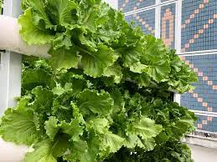Georgina Lettuce

Citiponics currently specializes in growing pesticide-free Georgina Lettuce, its unique in-house crossbreed lettuce mix.

Introduction to lettuce types：

<https://www.southernexposure.com/categories/lettuce/>

<https://www.youtube.com/watch?v=wj6hN9oQ4d4>

Romaine (Paris Island Cos)

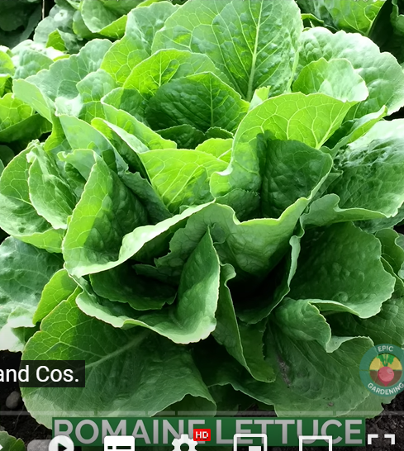

Loose leaf

Fast growth cycle

Ice berg

桌子上有一些绿色的蔬菜

中度可信度描述已自动生成 Slow growth cycle

Database：

1. [Download Lettuce labeled image classifcation dataset labeled image dataset (images.cv)](https://images.cv/dataset/lettuce-image-classification-dataset)

The shape is very messy - to check if it is lettuce

1. [3rd Autonomous Greenhouse Challenge: Online Challenge Lettuce Images (dataset) (4tu.nl)](https://data.4tu.nl/articles/_/15023088/1)

Datacite citation style：

S. (Silke) Hemming; H.F. (Feije) de Zwart; Elings, A. (Anne); monique bijlaard; Bart Marrewijk, van et. al. (2021): 3rd Autonomous Greenhouse Challenge: Online Challenge Lettuce Images. Version 1. 4TU.ResearchData. dataset. https://doi.org/10.4121/15023088.v1

3、photo of multiple mature lettuce：

<https://stock.adobe.com/sg/search?k=lettuce#state=%7B%22ac%22%3A%22stock.adobe.com%22%7D&token_type=bearer&expires_in=86399>

save：

<https://www.bing.com/saves?&FORM=savim2&collId=3>

1. Diseased lettuce:

[Lettuce NPK dataset | Kaggle](https://www.kaggle.com/datasets/baronn/lettuce-npk-dataset)

5、Green Vegetable Seedling Dataset:

<https://www.payititi.com/opendatasets/show-4615.html>

<https://www.payititi.com/opendatasets/list-51-2.html>

6、Kaggle Competition Seeding Classification：

[Plant Seedlings Classification | Kaggle](https://www.kaggle.com/competitions/plant-seedlings-classification)